**Question1: What is the difference between concurrency and parallelism?**

Concurrency is the composition of independently executing processes, while parallelism is the simultaneous execution of (possibly related) computations.

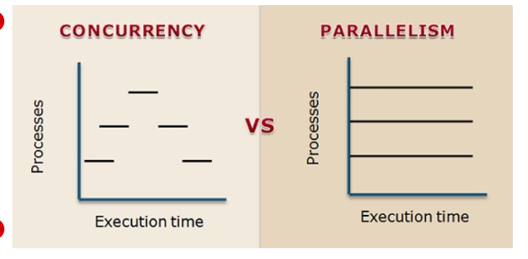

**Concurrency** means that an application is making progress on more than one task at the same time (concurrently). Well, if the computer only has one CPU the application may not make progress on more than one task at exactly the same time, but more than one task is being processed at a time inside the application (in overlapping time periods). It does not completely finish one task before it begins the next. Concurrency is related to how an application handles multiple tasks it works on.For example, multitasking on a single-core machine.

**Parallelism** is when tasks literally run at the same time. Parallelism means that an application splits its tasks up into smaller subtasks which can be processed in parallel, for instance on multiple CPUs at the exact same time (multicore processor).

Concurrency and parallelism are related terms but not the same. The crucial difference between concurrency and parallelism is that **concurrency** is about dealing with a lot of things at same time (gives the illusion of simultaneity) or handling concurrent events essentially hiding latency. On the contrary, **parallelism** is about doing a lot of things at the same time for increasing the speed.

**Question 2: How to change top refresh time? Change the default time to 10 seconds**

Write the command “top” , then enter s. When u will enter s after top command, the following statement will appear

“Change delay from 3.0 to ”

Now write 10 here so that the refresh time changes from 3 to 10 seconds.

**Question 3: How to send stop signal to a background process ( kill ? processID)**

kill -STOP processID or kill -19 processID

**Question 4: Array with 1000 elements ( )**

**Question 5: Client and server**

**Question 6: How many times “hello” and “exit” are printed?**

hello is printed 30 times and exit is printed 16 times.

